Epsom & Ewell F.C.
22
v
Spelthorne Sports
Tuesday, 1st March 2016 – 7.45 p.m.
Good evening! We welcome the players, supporters and officials of Spelthorne Sports for a League match, together with today’s match officials and our own regular supporters.

We must apologise once again for the reduced programme today. The reasons for this were explained in our previous issue. The Knaphill programme will be a larger issue once again.

This is the second attempt to play this game, following a very rare postponement at High Road on 16th January. Prior to that we won 6-2 over at Spelthorne in September and so a win today would complete a League double for the second season in a row.

We hosted local rivals Horley Town here on Saturday and unfortunately threw in our worst performance of the season in a 3-4 defeat. We trailed 1-4 at half time despite Rhys North’s great strike for his first goal for the club and only two late goals in injury time made the score respectable.

However, it should be pointed out that we have had very few poor performances this season; in fact we can only think of two, Ashford Town in the League Cup being the other, so it would be harsh to be too critical of our boys who are still having an excellent season. We also hear from a number of sources that Hartley Wintney may not go up if they win the title, as they still have much work to do on their ground so second place could contain a massive bonus. We still have much to play for if we can get back to winning ways quickly.

On Saturday we travel to Chertsey Town before returning here seven days later for matches with Knaphill (12th) and Cove (15th) in quick succession. Additionally, our postponed match at AFC Hayes has now been rescheduled for Tuesday 12th April.

The Super Six Predictor was won by three people on Saturday with many others coming close. All three won £81 and the jackpot kicks off again at £50 tonight.

Please note that there are plenty of matches still available to be sponsored and many players too. All contributions help your club. Today’s match is sponsored in memory of Chris Henry who was a very loyal supporter from 1969 until his passing in 2004.

The Programme Team

Keep up with us on Facebook www.facebook.com/epsomandewellfc and on Twitter @EEFCOfficial

Cover Photos by Gemma Jarman

- Matt Farrell scores the opener against Spelthorne here last December
- Matt Ferdinando smashes the ball in for our third goal in that match

Cherry Red Records Combined Counties League
Premier Division Table 2015/16
inc Saturday 27th February | P | W | D | L | F | A | Pts | GD | H | A
Hartley Wintney | 28 | 23 | 2 | 3 | 84 | 27 | 71 | +57 | 0-1 | 3-3
Ashford Town (Mx) | 30 | 22 | 2 | 6 | 81 | 38 | 68 | +43 | 30/4 | 3-2
Epsom & Ewell | 28 | 16 | 8 | 4 | 63 | 28 | 56 | +35 | - | -
Camberley Town | 25 | 17 | 5 | 3 | 50 | 21 | 56 | +29 | 16/4 | 1-1
Horley Town | 27 | 15 | 5 | 7 | 67 | 38 | 50 | +29 | 3-4 | 2-2
Colliers Wood United | 33 | 15 | 4 | 14 | 66 | 57 | 49 | +9 | 3-1 | 3-0
Hanworth Villa | 28 | 15 | 3 | 10 | 52 | 41 | 48 | +11 | 5-0 | 23/4
Spelthorne Sports | 30 | 11 | 9 | 10 | 54 | 57 | 42 | -3 | 1/3 | 6-2
Raynes Park Vale | 28 | 13 | 2 | 13 | 55 | 53 | 41 | +2 | 3-1 | 28/3
Guildford City | 30 | 11 | 6 | 13 | 57 | 65 | 39 | -8 | 4-0 | 2/4
Knaphill | 23 | 12 | 2 | 9 | 52 | 36 | 38 | +16 | 12/3 | 1-1
Windsor | 29 | 10 | 8 | 11 | 51 | 56 | 38 | -5 | 2-2 | 1-2
AFC Hayes | 30 | 10 | 6 | 14 | 44 | 56 | 36 | -12 | 1-1 | 12/4
Farnham Town | 24 | 10 | 4 | 10 | 46 | 38 | 34 | +8 | 1-0 | 22/3
Badshot Lea | 28 | 11 | 1 | 16 | 41 | 71 | 34 | -30 | 9/4 | 1-0
Sutton Common Rovers | 28 | 10 | 3 | 15 | 49 | 58 | 33 | -9 | 3-1 | 2-1
Bedfont Sports | 28 | 8 | 8 | 12 | 39 | 40 | 32 | -1 | 1-0 | 2-2
Chertsey Town | 29 | 8 | 6 | 15 | 40 | 52 | 30 | -12 | 0-1 | 5/3
Westfield | 23 | 7 | 6 | 10 | 27 | 41 | 27 | -14 | 26/3 | 0-0
Chessington & Hook | 26 | 7 | 2 | 17 | 42 | 67 | 23 | -25 | 1-0 | 19/3
Redhill | 23 | 3 | 3 | 17 | 28 | 60 | 12 | -32 | 3-0 | 1-0
Cove | 27 | 1 | 1 | 25 | 19 | 105 | 4 | -86 | 15/3 | 7-0

Lucky Day? – 1st March
Played 16 - W 5 D 4 L 7 - F 26 A 29 - PPG 1.19 - Below Average
Our Club record against today’s visitors
Played 4 - W 3 D 1 L 0 - F 13 A 5 - PPG 2.50 - Fantastic
Largest wins and losses against today’s visitors
12th September 2015 - (A) W 6-2 - League
24th April 2014 - (H) D 0-0 - Southern Combination Cup (lost 4-2 on penalties)
Their Last visit
Tuesday 16th December 2014 - W 4-3 - Combined Counties League

From behind the goal
Epsom & Ewell 3-4 Horley Town
Combined Counties League – Premier Division – Saturday 27th February 2016

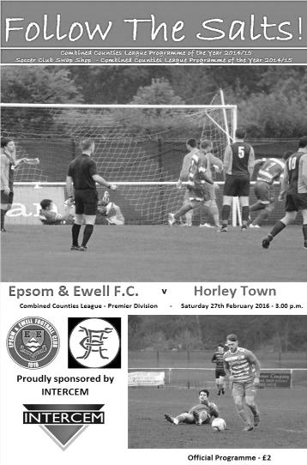
First half disaster gift wraps the points to Horley

A chilly and windy day met the spectators at High Road and the home supporters had little to cheer as the visitors got off to a flyer and never looked back, winning with a score line that flattered Epsom and Ewell, thanks to two late goals for the home side.

Epsom got off to the worst possible start as a shot from Connor Power took a deflection, swirled in the wind and deceived Michael Eacott in the Epsom goal in just the second minute. However, a fine twenty yard strike from Rhys North brought us level in the 12th minute. Unfortunately, fouls by Matt Tanton and Bentley Graham in quick succession led to a couple of Horley penalties, both converted by Ashley Nadesan after 23 and 29 minutes and an unfortunate defensive miskick after 42 minutes went straight to him, leaving a simple header past the exposed Eacott after 42 minutes.

Epsom were given a lifeline after 58 minutes when Power picked up two yellow cards in quick succession, the first for kicking the ball away and the second for a challenge from behind and the visitors were down to ten men, as they had been in the previous fixture in December. Despite this Epsom were unable to take any real advantage until all three substitutes had come on, all of which were involved. Rob Hendry finished a perfect Matt Ferdinando cross with a glancing header after 91 minutes and a couple of minutes later Kyle Hough scored from the spot after Reisse Griffin had been brought down.

But it was too little too late and Epsom fell to their second straight defeat, following a performance that was said by many after the game to be our worst of the season by some way.

Team: Michael Eacott, Rhys North, Matt Tanton, Craig Hastings, James Taylor, Matt Farrell (c), Savvas 'Agi' Panayiotou, Bentley Graham, Tom Neale, Elliott Thompson, Matt Ferdinando

Subs: Kyle Hough for Panayiotou (52), Rob Hendry for Thompson (70), Reisse Griffin for Tanton (78)

Latest Results and Fixtures
Combined Counties League – Friday 26th February
Colliers Wood United | 2-1 | Sutton Common Rovers
Combined Counties League – Saturday 27th February
Badshot Lea | 0-2 | Raynes Park Vale
Bedfont Sports | 4-1 | Redhill
Chessington & Hook United | p-p | Camberley Town
Cove | 1-3 | AFC Hayes
Epsom & Ewell | 3-4 | Horley Town
Farnham Town | 4-2 | Hartley Wintney
Guildford City | 2-1 | Windsor
Hanworth Villa | 0-3 | Ashford Town (Mx)
Spelthorne Sports | 1-1 | Chertsey Town
Westfield | 1-6 | Knaphill
Combined Counties League Cup QF – Tuesday 1st March
Camberley Town | V | Colliers Wood United
Chessington & Hook United | V | Ashford Town (Mx)
Cobham | V | Westfield
Knaphill | V | Farnham Town
Combined Counties League – Tuesday 1st March
AFC Hayes | V | Badshot Lea
Bedfont Sports | V | Cove
Epsom & Ewell | V | Spelthorne Sports
Hanworth Villa | V | Sutton Common Rovers
Redhill | V | Guildford City
Combined Counties League – Saturday 5th March
Camberley Town | V | Westfield
Chertsey Town | V | Epsom & Ewell
Cove | V | Chessington & Hook United
Farnham Town | V | Bedfont Sports
Guildford City | V | Badshot Lea
Hartley Wintney | V | Knaphill
Horley Town | V | AFC Hayes
Raynes Park Vale | V | Colliers Wood United
Redhill | V | Ashford Town (Mx)
Combined Counties League – Saturday 5th March
Sutton Common Rovers | V | Spelthorne Sports
Windsor | V | Hanworth Villa
Combined Counties League – Tuesday 8th March
Bedfont Sports | V | Windsor
Chessington & Hook United | V | Farnham Town
Horley Town | V | Chertsey Town
Knaphill | V | Badshot Lea
Raynes Park Vale | V | Ashford Town (Mx)
Redhill | V | Spelthorne Sports
Westfield | V | Cove
Combined Counties League – Thursday 10th March
Westfield | V | Guildford City
Latest Results and Fixtures
Combined Counties League – Saturday 12th March
AFC Hayes | V | Raynes Park Vale
Ashford Town (Mx) | V | Bedfont Sports
Badshot Lea | V | Cove
Camberley Town | V | Windsor
Chessington & Hook United | V | Hartley Wintney
Colliers Wood United | V | Horley Town
Epsom & Ewell | V | Knaphill
Hanworth Villa | V | Farnham Town
Redhill | V | Sutton Common Rovers
Spelthorne Sports | V | Guildford City
Westfield | V | Chertsey Town

Player Profile – Number 15 – Sam Currie
Our latest profile is from our club Captain Sam Currie who is the man to thank for getting the players to fill in these profiles in the first place. Now it’s his turn!

Age: 30

Position: Defender

Club supported: Arsenal
Favourite Food: Ham, egg and chips

Favourite Film: Cool Runnings

Messi or Ronaldo: Messi

Favourite Drink: Fresh Orange Juice

Favourite Ground played at: Windsor FC

Best moment for Epsom and Ewell FC: Scoring Epsom’s third goal from distance in the League Cup Final at Farnborough FC

Describe the Gaffa in three words: A – Diamond – Geeza!

Congratulations Matt!
Congratulations go to Matt Tanton who should make his 50th appearance for the club tonight.

Matt was briefly with our title winning Reserves in the Surrey Elite League during 2013/14 and also spent some time at Colliers Wood United before making his first team debut along with many others at Farnham on 2nd August 2014. University studies curtailed his season but he was back at the start of the new term, proving extremely reliable and like a good defender is most noticeable when he is not here.

He has been unlucky with suspensions this season and was wrongly sent off at Bedfont Sports. As a result his only misdemeanour was to kick the ball away at home to Sutton Common Rovers and that second yellow caused him to miss two more games. Harsh!

Matt becomes the 261st player in club history to reach this milestone and hopefully many more appearances will follow.

Spelthorne Sports F.C. – History
Spelthorne Sports Club was founded in 1922 having purchased around 11 acres of land and has been providing sports for the local community ever since. We currently have 2 full sized football pitches and field 3 adult football teams and 2 Sunday teams along with a Youth Section covering Little Kickers through to the Mid-week Flood Lit Under 18’s, a total of 21 youth teams competing every Sunday in the Surrey Youth and Surrey Primary Leagues. The Youth Section was awarded the FA Charter Standard in March 2010 and the Annual Youth Tournament draws in many local teams since its inauguration in 2010.

In season 1998-99, Richard Ford and Micky Fisher took control of their 1st full season and saw them rise up the table. Both players were long serving Spelly players and had now moved into the management side. The team were led by Paul Fernadez with Paul Wilson in goal and Ian & Nick Croxford playing their 1st seasons with Spelly. We finished the season in 3rd spot and reached the final of the Russell Grant cup, where Sports did their usual thing of blowing it and lost to Northolt Saints 2-0 in the final at Uxbridge after they had beaten and drawn with them earlier in the season. (P18 W10 D5 L3 F35 A18 P35)

2001 was the first season of the new management team of Paul Martyn Jones (Trigger) and Ian Croxford. The team had the two scoring machines of James (OGGY) Hogg and Nick Croxford playing up front and with eventual player of the year Wes Coles in goal this was the most successful season for many a year. The team went from October through to April without losing a league game taking the league title in front of Willesden Constantine by 5 points, they were on the road to a league and cup double but were beat in the semi-finals by Willesden with future professional footballer Enoch Showammi smashing home a 25 yard free kick.

In 2007, after many great years playing in the Middlesex League it was decided that a move to the Surrey League was required. The main driving force for this was that the league had expanded so that games were all across London and for an Amateur side, an away trip to Bethnal Green was an all-day event!

The move to the Surrey Intermediate League Western Division was a change that was needed with pleasant drives through the country playing village teams rather than long hauls across London.

With the management now in the hands of Steve Flatman, a long time player and member of the club, the team saw a steady growth and this has to be credited to Steve. The first season saw Sports finish 7th (P26 W10 D10 L6 F50 A39 P40) with Horsley running away with the league. The next season saw some old faces come back into the team to support the young bucks with Oggy, Mike Jenkins and Ian Croxford coming back to support the team. The team finished second behind Ripley with Rob Smith finishing top league scorer with 21 and Lee Staples not far behind on 19.

The season had its climax when Sports played their first final in many a year against Abbey Rangers at a very dusty Cobham FC and with the team leading 1-0 at half time through a Jake

Flatman goal they somehow grabbed defeat from the jaws of victory losing 2-1 with a spectacular 20 yard own goal from Aaron Stewart.

In 2009, Spelthorne Sports again moved leagues for the second time in three seasons as we progressed up through the FA pyramid system, this time to the Surrey Elite league. The season started well but it was discovered that a (nameless) player had played with a ban from his now disbanded Sunday team. This resulted with Spelly being deducted all points that had been awarded while he was playing that season, 9 in total. Spelly finished the season 5th (P28 W17 D1 L10 F70 A52 P43) if we had not lost the points we could possibly have finished third or even higher as the disappointment of losing these points was a bitter pill to swallow.

In the 2010-11 season Spelthorne Sports Football Club 1st Eleven Completed a league and cup double victory by winning the Surrey Elite Intermediate League and the Surrey Intermediate Challenge Cup. Their league success means they won promotion to the Combined Counties League. Steve Flatman continues to be involved with the football section and is always on call!

In 2013–14, the Spelly won the Middlesex FA Intermediate Cup, beating Middlesex County Premier side Cricklewood Wanderers 3–0 in the Final. On 16 April 2014, Spelthorne Sports were crowned Combined Counties Division One Champions with a 2–1 win away to Epsom Athletic. They lifted the trophy three days later following an emphatic 7–0 win at home to local rivals Staines Lammas. We also won the RPM Records Division One Challenge Cup against Staines Lammas at Windsor FC on 5 May 2014. A single second half Lee Staples goal was enough to make sure we lifted the trophy, winning the league and cup treble in the process.

The team went on a phenomenal 46 game unbeaten run in all competitions that season, beating teams in cup competitions from higher divisions such as Frimley Green, Staines Town (on penalties), Walton Casuals, Wembley, and Epsom & Ewell (on penalties). That unbeaten run finally came to an end on 7 May 2014 when they played Combined Counties Premier Division side Hanworth Villa in the Southern Combination Cup Final, losing 1–0. The game was played at home and marked the club's first ever game under the newly installed floodlights. The lads then suffered their second defeat of the season to the same opposition when the sides met again three days later in the Cherry Red Records Premier Challenge Cup Final, again losing 1–0.

It was an extremely successful for the club. Winning two cup finals, and finishing runners-up in another two cup finals. However the biggest achievement by far was winning the League without losing a single game in the process. Winning 22, drawing 8, losing 0, scoring 92, and conceding 23.

Season 2014-2015 saw us in action in the Combined Counties Premier Division where we finished in a very respectful 6th position. We also experienced our first entry into the FA Vase. The promotion led to vast ground improvements yet again and this work continues to be done.

This season sees a change of management back under the control of Steve Flatman with support from Paul Burgess and Mark Harper. We are looking forward to seeing the continued development of football at ‘The Spelly’.

Centre page for results

Centre page for results

Player Sponsorship
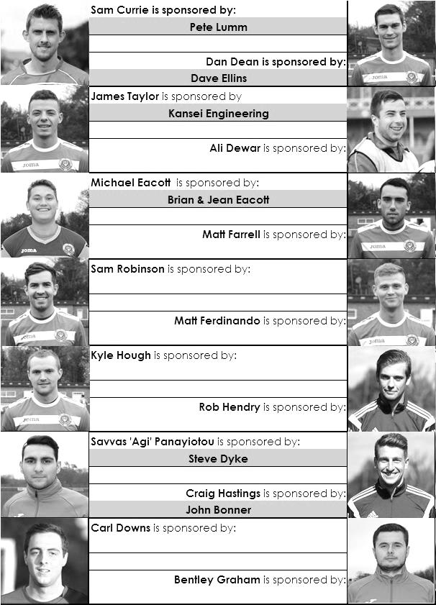

Here is the current list for the 2015/16 season showing all of our players and Management that are currently available for sponsorship this season.

Sponsorship costs just £40 and it is easy to do. Just select a player who has not been previously sponsored and let a Committee Member know that you would like to sponsor them. Beware though. Until we have received the money it is possible for someone to jump in front of you, so don’t delay, sponsor today!
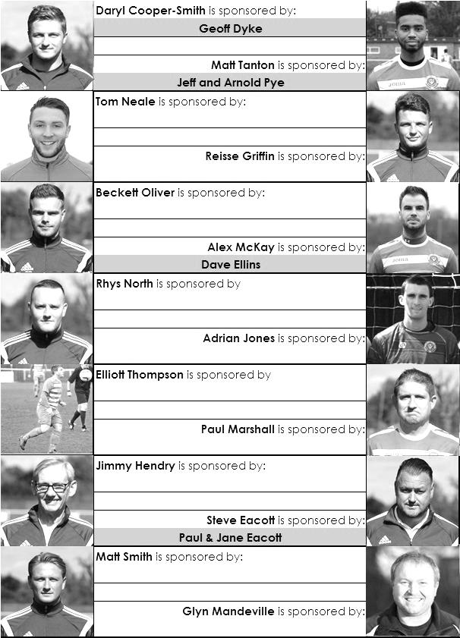

CCL Premier Division Club Directory
A.F.C. HAYES Telephone: 0208-845-0110 - Ground: Farm Park, Kingshill Avenue, Hayes, Middx. UB4 8DD - Colours: Blue and White Stripes/Blue/Blue

ASHFORD TOWN (Mx) Telephone: 01784-245908 - Ground: The Robert Parker Stadium, Short Lane, Stanwell, Middx. TW19 7BH - Colours: Tangerine & White Stripes/Black/Tangerine

BADSHOT LEA Telephone: 01252-320385 - Ground: Ash United FC, Shawfield Stadium, Youngs Drive, Shawfields Road, Ash, Hampshire. GU12 6RE - Colours: Claret/White/Claret

BEDFONT SPORTS Telephone: 0208-831-9067 - Ground: Bedfont Sports Club, Hatton Road, Bedfont, Middx TW14 8JA - Colours: Red & Black Hoops/Black/Red & Black Hoops

CAMBERLEY TOWN Telephone: 01276-65392 - Ground: Krooner Park, Wilton Road, Camberley, Surrey. GU15 2QW - Colours: Red & White Stripes/Blue/Red

CHERTSEY TOWN Telephone: 01932-561774 - Ground: Alwyns Lane, Chertsey, Surrey. KT16 9DW - Colours: Royal Blue & White Stripes/Royal Blue/Royal Blue

CHESSINGTON & HOOK UNITED Telephone: 01372-602263 - Ground: Chalky Lane, Chessington, Surrey. KT9 2NF - Colours: Blue/Blue/Blue

COLLIERS WOOD UNITED Telephone: 0208-942 8062 - Ground: Wibbandune Sports Ground, Robin Hood Way, Wimbledon. SW20 0AA - Colours: Blue & Black Stripes/Black/Black

COVE Telephone: 01252-543615 - Ground: Oak Farm Fields, 7 Squirrel Lane, Cove, Farnborough, Hampshire. GU14 8PB - Colours: Yellow/Black/Yellow

EPSOM & EWELL Telephone: 01737-553250 - Ground: Chipstead FC, High Road, Chipstead, Surrey. CR5 3SF - Colours: Royal Blue & White Hoops/Royal Blue/Royal Blue & White Hoops

FARNHAM TOWN Telephone: 01252-715305 Ground: Memorial Ground, Babbs Mead, West Street, Farnham, Surrey. GU9 7DY Colours: - Claret & Sky Blue /White/ Claret & Sky Blue

GUILDFORD CITY Telephone: 01483-443322 - Ground: The Spectrum, Parkway, Guildford, Surrey. GU1 1UP - Colours: Red & White Stripes/Black/Black

HANWORTH VILLA Telephone: 0208-831-9391 - Ground: Rectory Meadows, Park Road, off Hounslow Road, Hanworth, Middlesex. TW13 6PN - Colours: Red & White Stripes/Black/Black

HARTLEY WINTNEY Telephone: 01252-843586 - Ground: Memorial Playing Fields, Green Lane, Hartley Wintney, Hants RG27 8DL - Colours: Orange & Black/ Orange /Orange

HORLEY TOWN Telephone: 01293-822000 - Ground: The New Defence, Anderson Way, Court Lodge Road, Horley, Surrey. RH6 8SP - Colours: Claret & Sky Blue/Claret/Claret

KNAPHILL Telephone: 01483-475150 - Ground: Brookwood Country Park, Redding Way, Lower Guildford Road, Knaphill, Surrey. GU21 2AY - Colours: Red/Black/Red

SUTTON COMMON ROVERS Telephone: 01932-866386 - Ground: Sutton United FC, Gander Green Lane, Sutton, Surrey SM1 2EY - Colours: Yellow/Black/Black

RAYNES PARK VALE Telephone: 020-8540-8843 - Ground: Prince Georges Playing Field, Grand Drive, Raynes Park, London. SW20 9NB - Colours: Blue/Blue/Red

REDHILL Telephone: 01737-762129 - Ground: Kiln Brow, Three Arch Road, Redhill, Surrey RH1 5AG - Colours: Red and White Stripes/Black/Red

SPELTHORNE SPORTS Telephone: 01932-961055 - Ground: Spelthorne Sports Club, 296 Staines Road, Ashford Common, Ashford, Middx. TW15 1RY - Colours: Light & Dark Blue/Dark Blue/Light Blue

WESTFIELD Telephone: 01483-771106 - Ground: Woking Park, Kingfield Road, Woking, Surrey. GU22 9BA - Colours: Yellow/Black/Black

WINDSOR Telephone: 01753-860656 - Ground: Stag Meadow, St Leonards Road, Windsor, Berks SL4 3DR - Colours: Red/Red/Red

Match and Ball Sponsorships – 2015/16
Opponent | Date | Match Sponsor | Match Ball Sponsor
Hoddesdon Town | 18/07/15 | Geoff Dyke
Windsor | 08/08/15 | Club President - Stella Lamont
Erith & Belvedere (FAC) | 16/08/15 | Committee Member - Mike Lovett
Raynes Park Vale | 31/08/15 | EEFC Management Committee
Colliers Wood United | 08/09/15 | Bookham Building Shop – www.buildingshop.co.uk
AFC Hayes | 19/09/15 | John Bonner
Farnham Town | 26/09/15 | Ezara and Inaya Beddoe – our youngest supporters!
Chertsey Town | 17/10/15 | Club Media Officer – Richard Lambert
Dorking Wanderers (SSC) | 20/10/15 | Tony Ferdinando
Chessington & Hook United | 07/11/15 | Paul Merritt
Hanworth Villa | 21/11/15 | Maggie Beddoe
Guildford City | 05/12/15 | Pete Lumm
Sutton Common Rovers | 19/12/15 | Marvin Hough
Ashford Town (Mx) (LC) | 12/01/16 | Pete Beddoe & Steve Dyke
Redhill | 02/02/16 | David Lawton
Bedfont Sports | 13/02/16 | Bookham Building Shop – www.buildingshop.co.uk
Hartley Wintney | 23/02/16
Horley Town | 27/02/16
Spelthorne Sports | 01/03/16 | In memory of Chris Henry
Knaphill | 12/03/16
Cove | 15/03/16
Westfield | 26/03/16 | Nathan Lambert
Badshot Lea | 09/04/16
Camberley Town | 16/04/16
Ashford Town (Mx) | 30/04/16 | Club President - Stella Lamont
Ashford Town (Mx) | 30/04/16 | Brian Eacott | Steve Dyke
For League, League Cup and Surrey Senior Cup Matches:
Match sponsorship - £40.00 Match ball sponsorship - £25.00. Combined £55.00.
For F.A. Cup and F.A. Vase matches:
Match sponsorship - £50.00 Match ball sponsorship - £30.00. Combined £65.00.

Sponsorship includes: ( x2 for match, x3 for match and ball )

Admission, programmes, hospitality, advertising and mascot for the day (if required ).
If you are interested, just speak to a Committee Member, or drop me an email at: richard.c.lambert@gmail.com

We also thank our Kit Sponsors INTERCEM

Combined Counties League – Premier Division
Tuesday, 1st March 2016 - Kick-off 7.45 p.m.
Epsom and Ewell  (Royal Blue & White hoops) | V |  | Spelthorne Sports  (All White)
Squad | NUMBERS |  | Squad
Michael Eacott |  |  | Dane Buss
Rhys North |  |  | Billy Roach
Matt Tanton |  |  | Junior Wright
James Taylor |  |  | Qaseem Soronwa
Craig Hastings |  |  | Frankie Law
Bentley Graham |  |  | Callum Mackay
Savvas ‘Agi’ Panayiotou |  |  | Simo Mbonkwi
© Matt Farrell |  |  | Jake Hicks
Tom Neale |  |  | Lee Staples
Elliott Thompson |  |  | Conor Moody
Matt Ferdinando |  |  | Ashley Quashie
Kyle Hough |  |  | Jake Flatman
Reisse Griffin |  |  | Joe Goodman
Sam Robinson |  |  | Joe Lynch
Rob Hendry |  |  | Simon Murray
Alex McKay |  |  | Clint Church
Adrian Jones
Sam Currie
Beckett Oliver
Carl Downs
Dan Dean
Glyn Mandeville | MANAGER |  | Steve Flatman
Matt Smith | ASSISTANT |  | Paul Burgess / Mark Harper
Steve Eacott / Alex McKay / Jimmy Hendry | COACHES / PHYSIO
REFEREE: T.Dowdeswell (Epsom)
ASSISTANTS: K.Parker (Roehampton), I.Hempel (Chessington)
Our match and match ball today are sponsored
in memory of long-serving supporter Chris Henry

OUR NEXT VISITORS TO HIGH ROAD ARE:
Knaphill
Saturday 12th March 2016 - Kick-off 3.00 p.m.
Combined Counties League – Premier Division

